|  |  |
| --- | --- |
| Course Name | ITD 3243 – Server Side Programming |
| Instructor | Mark L. Pranger |
| Student Name | Derrick McFall |
| Due date | 06Feb19 |
| Grade | <grade earned here> |
| Grading Comments | <instructor comments here> |

Module 5

Book Exercise 7-1

Steps 1 to 10

Open and test the application

1. Start the Chrome browser and run the application in the ex_starts\ch07_ex1 directory. To do that, you can use this URL:

http://localhost/ex_starts/ch07_ex1/

This should display a form that has a variety of controls.

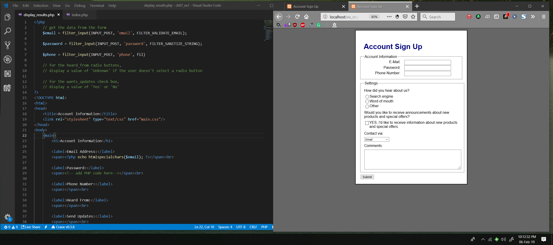

2. Enter some data, including a valid email address, and click on the Submit button. This should only display the data that you entered for the email address.

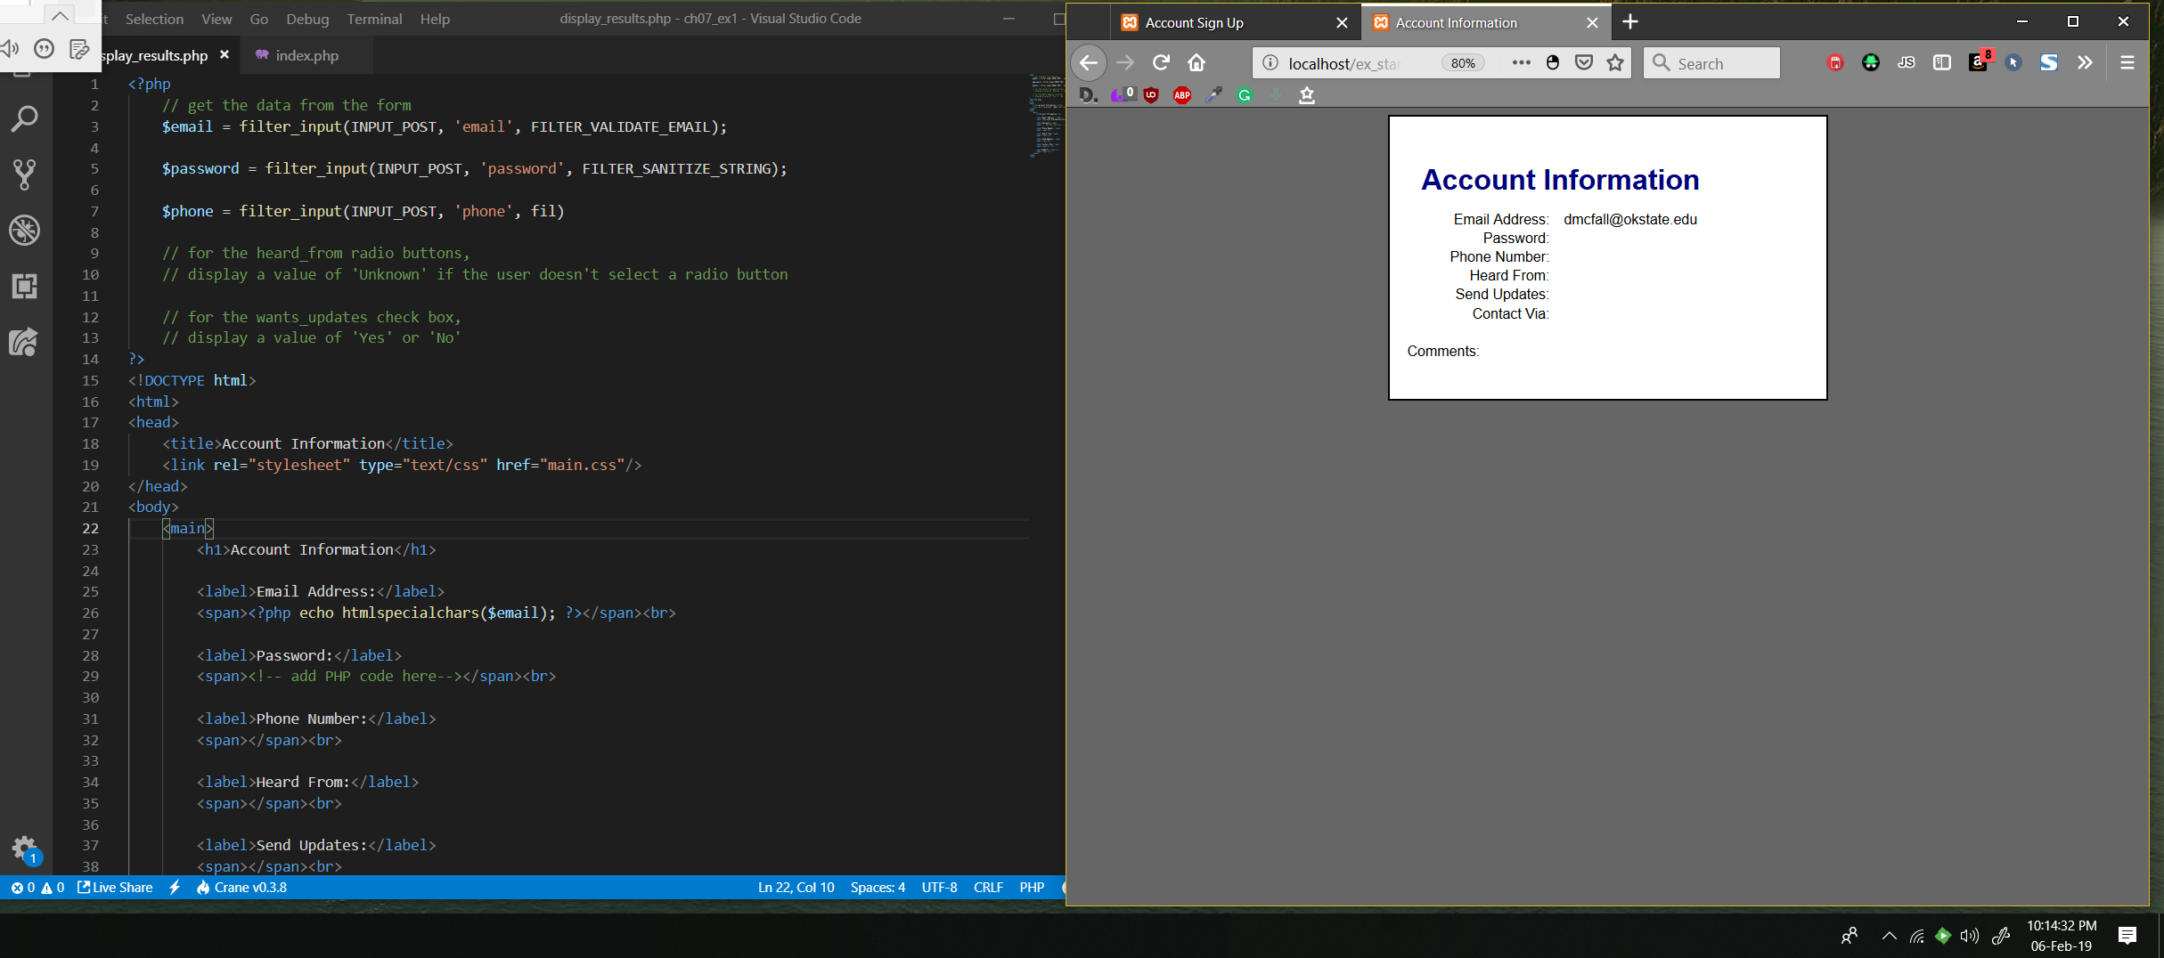

3. Open the index.php file for this application and review the code. Note the names that are used for the various input controls.

Steps 3 and 4 have you take note of certain names.  On those screen shots highlight or otherwise indicate those names they want you to take note of for those steps.

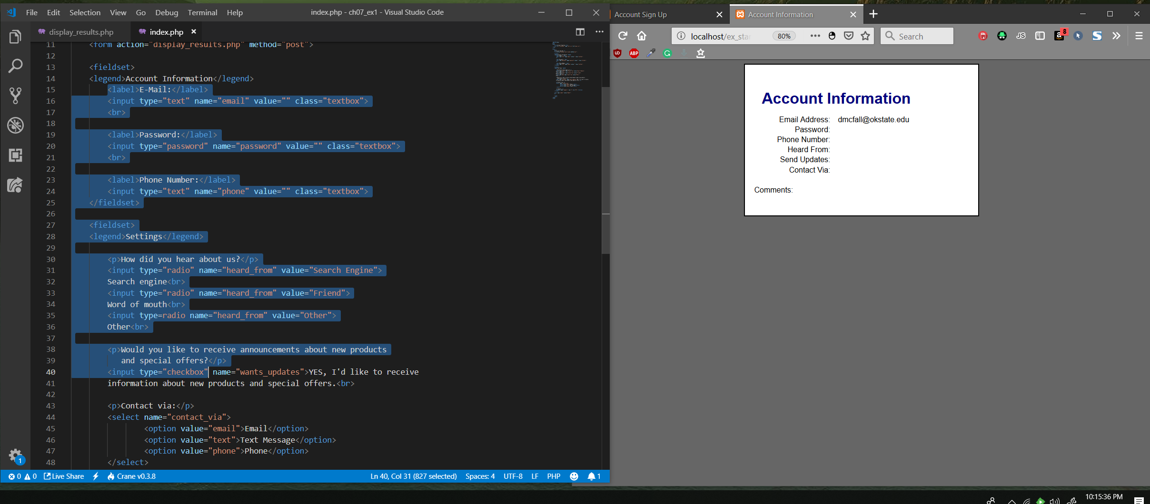

4. Open the display_results.php file for this application and review the code. Note that most of the code that gets data from the controls is missing. In addition, most of the code that displays this data is missing.

Steps 3 and 4 have you take note of certain names.  On those screen shots highlight or otherwise indicate those names they want you to take note of for those steps.

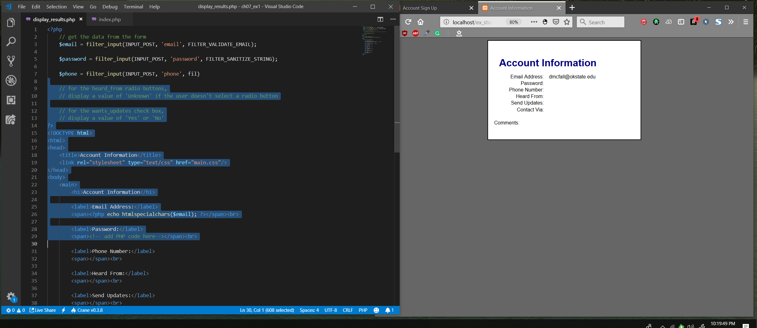

5. Add the code that gets the data from the controls on the first page. Then, add the code that displays this data.

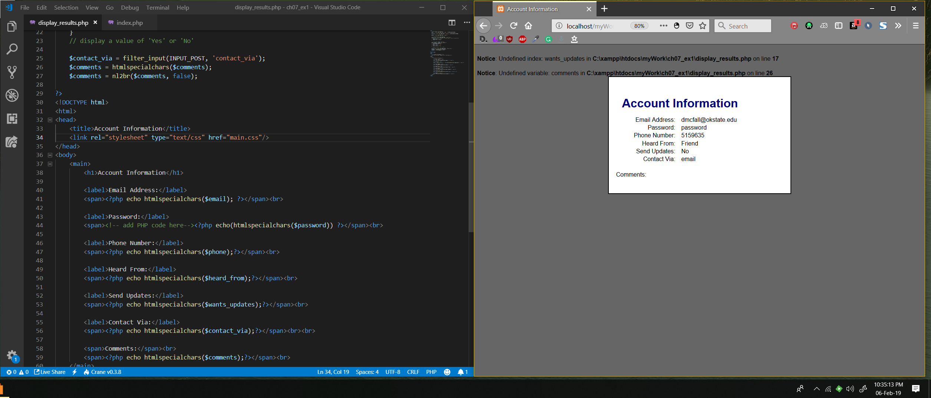

6. For the radio buttons, display a value of “Unknown” if the user doesn’t select a radio button.

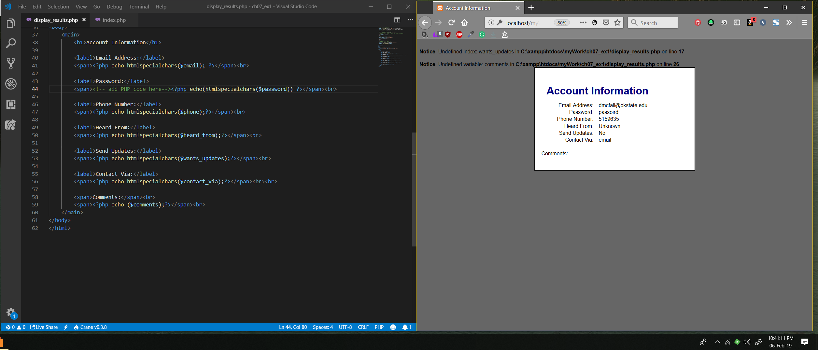

7. For the check box, display a value of “Yes” or “No” depending on whether the user has selected the check box.

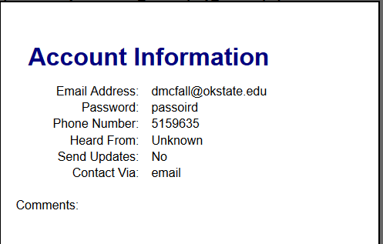

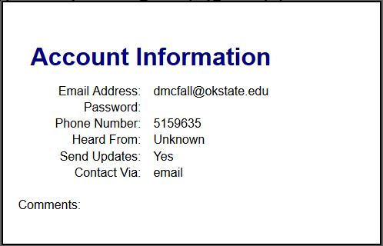

8. For all fields that allow the user to type text into the field, make sure to convert special characters into HTML entities before displaying that data on the second page as described in figure 7-8.

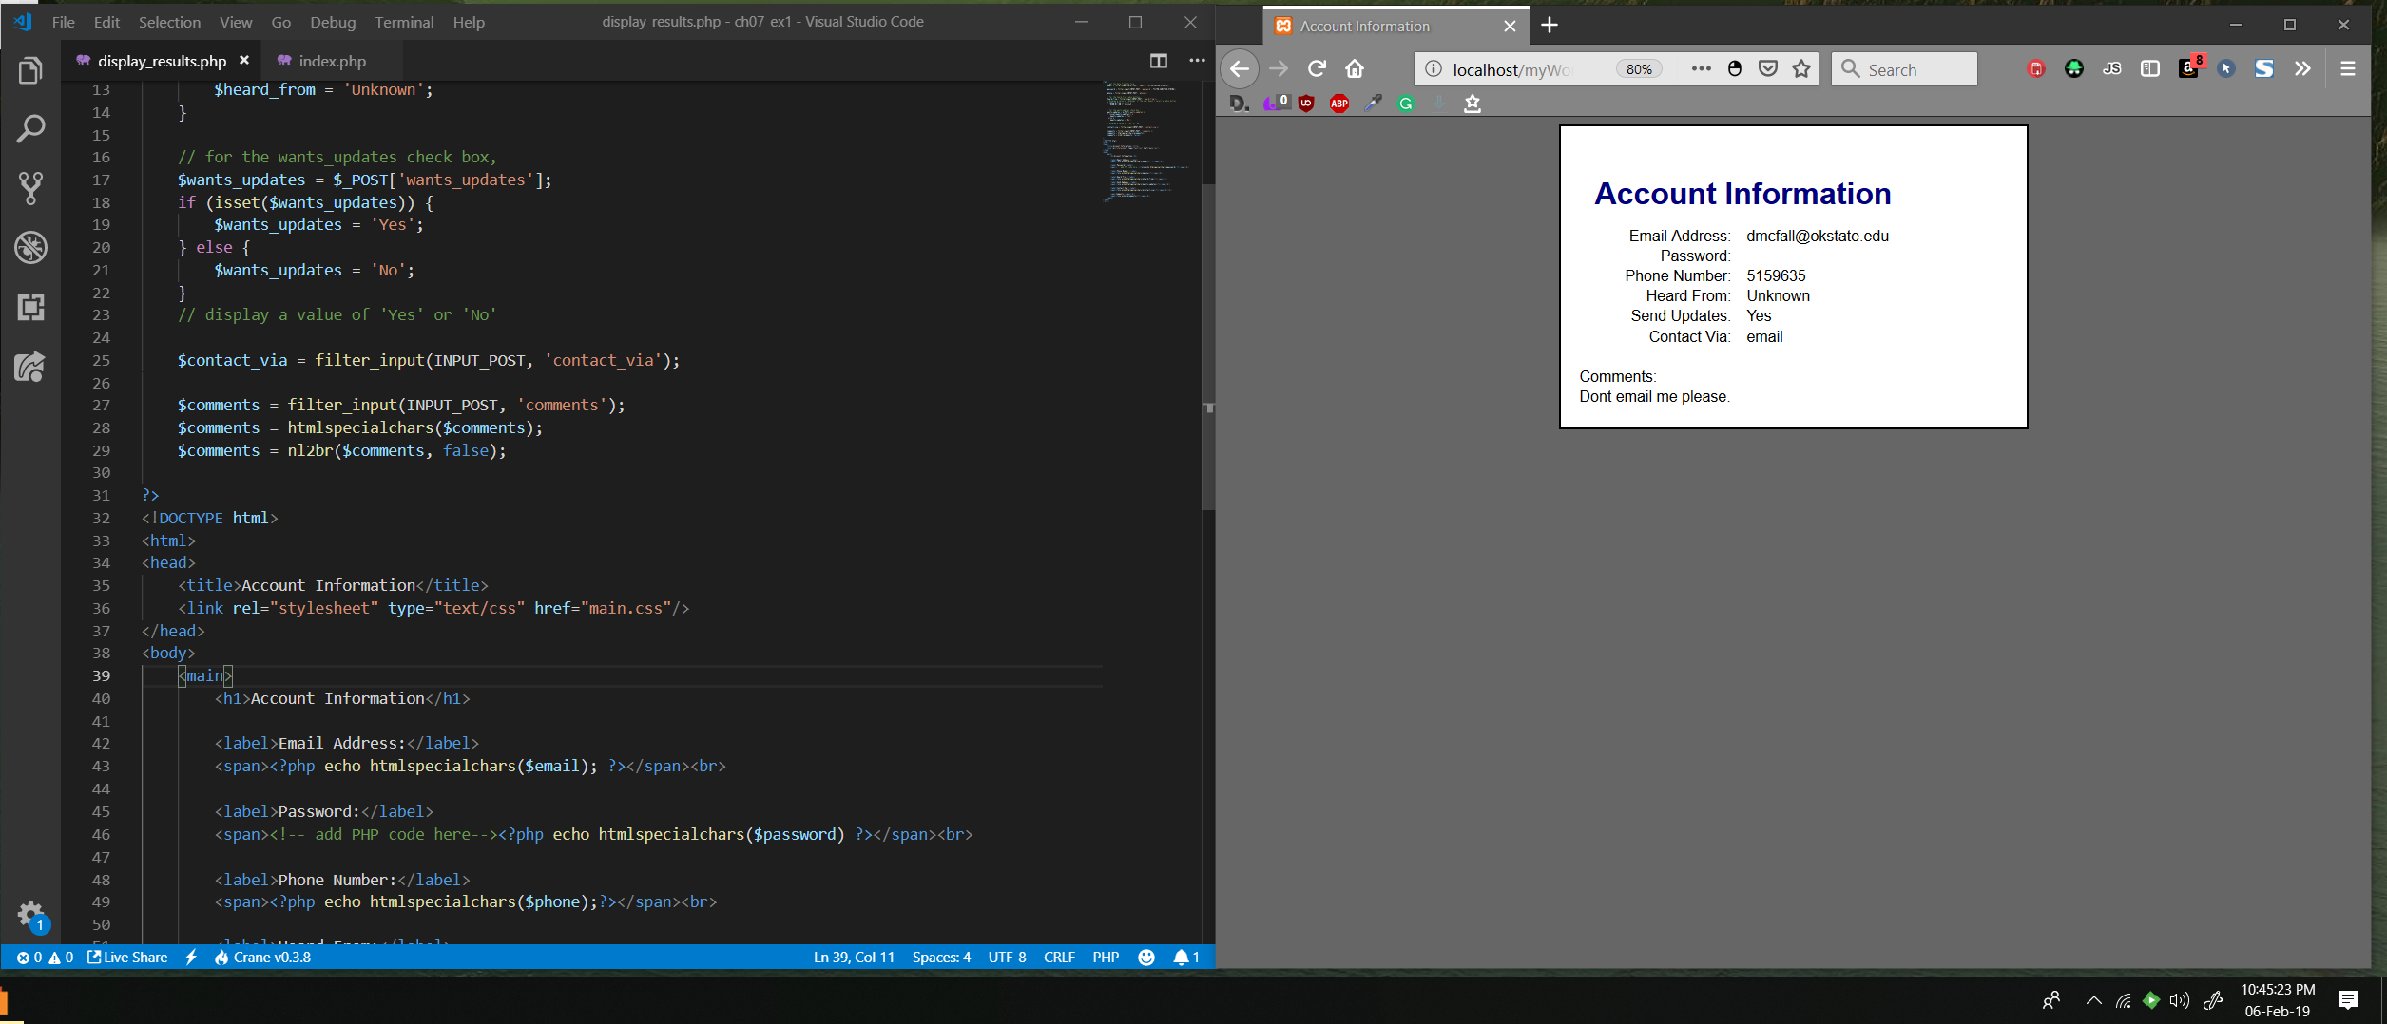

Comments weren’t showing up. I realized that I wasn’t filtering the input from the comments, just the other inputs.

9. For the comment field, make sure to convert new line characters to <br> tags so the web page can display new line characters correctly.

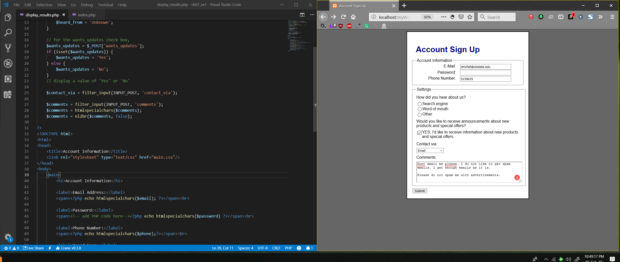

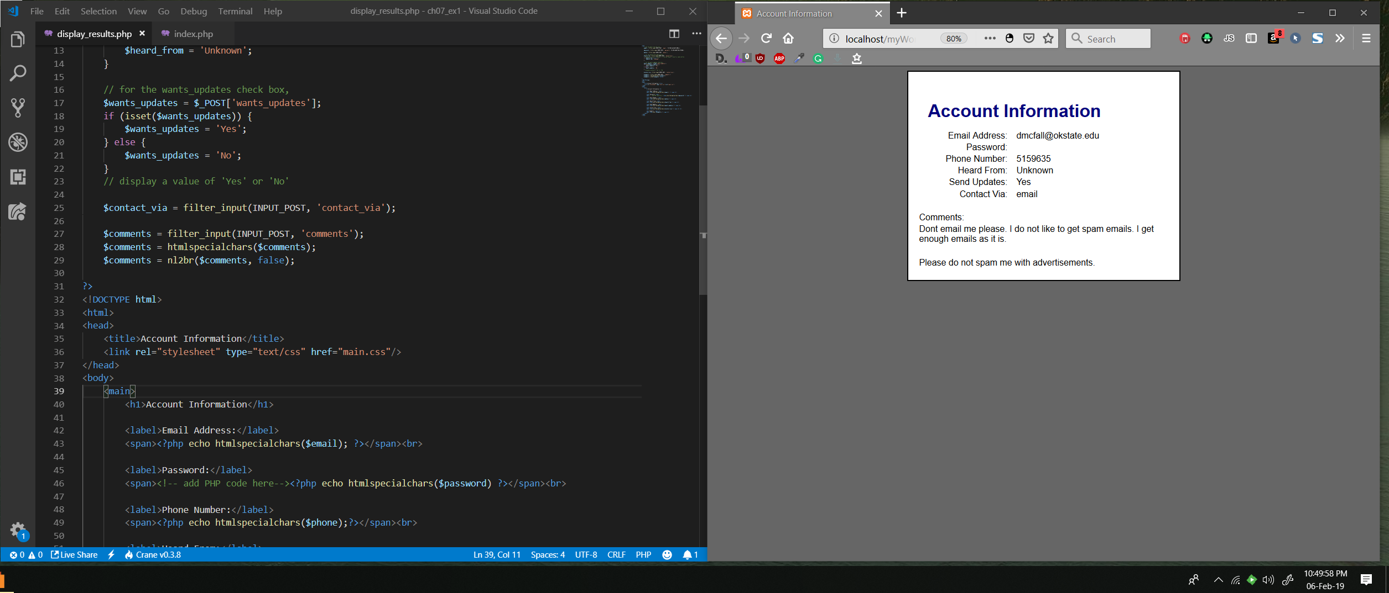

As shown on page 227, the nl2br function puts and html <br> in the place of the newline characters.

10. Test the application to make sure it works correctly. To do that, you can test text fields with special characters such as the ampersand (&), and you can press the Enter key in the comments field to enter a new line character.

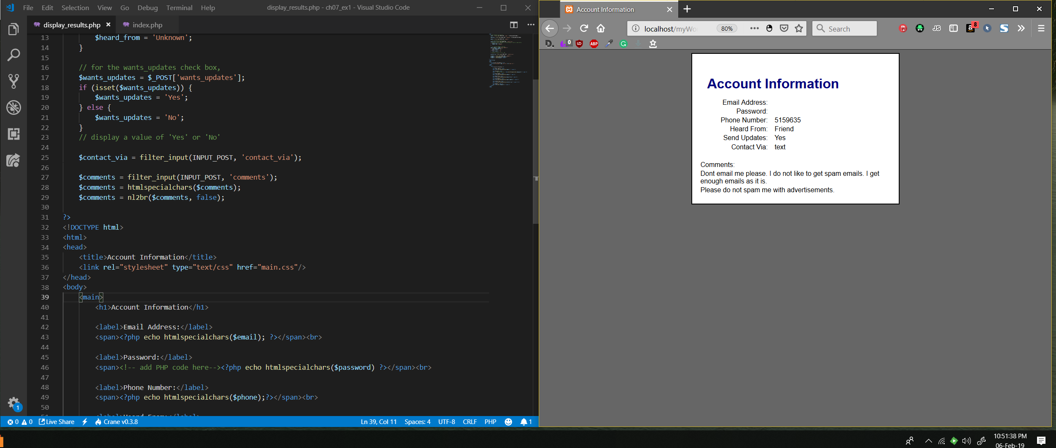

Email doesn’t show up at all if the ‘@’ symbol was left off. This is from the validate email filter.

Book Exercise 7-2

Steps 1 to 7

In this exercise, you will enhance the Future Value application of chapter 2 so it uses drop-down lists instead of text boxes.

Open and test the application

1. Start the Chrome browser and run the application in the ex_starts\ch07_ex2 directory. This should display the first page of a Future Value application that’s similar to the one presented in chapter 2. Note that this page displays three default values in the three text boxes.

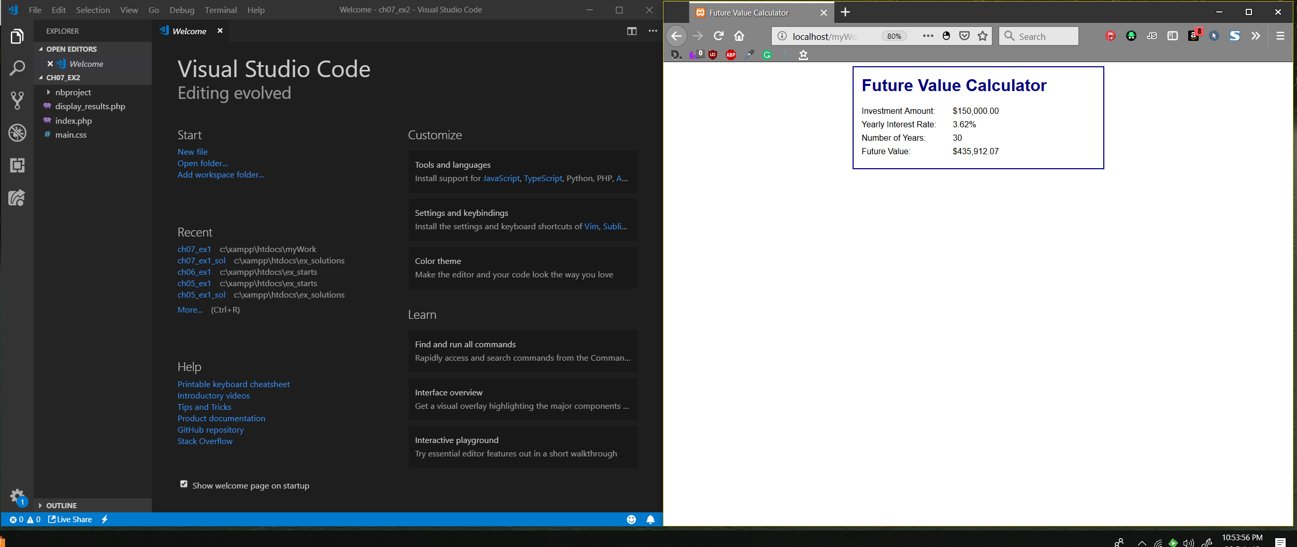

2. Click the Calculate button to perform the calculation. Note that this displays the correct future value calculation on the second page.

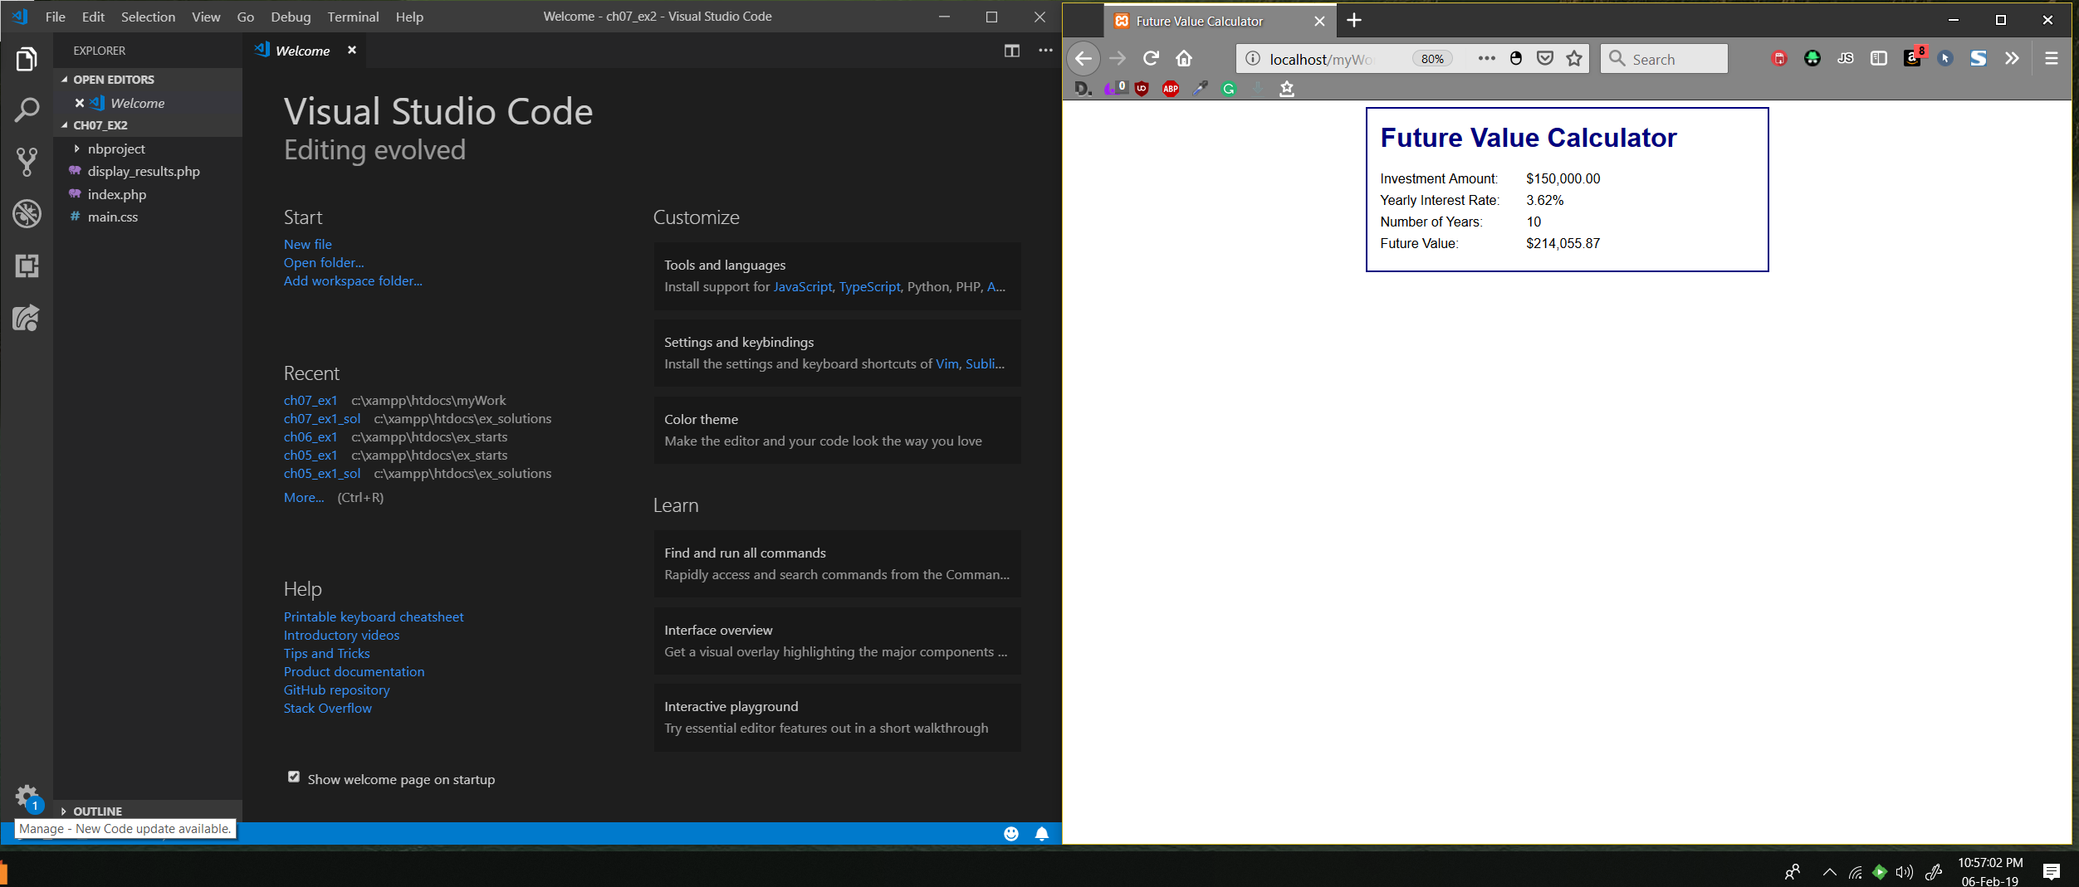

3. Open the index.php file for this application and review the code. Note the names that are used for the three text boxes.

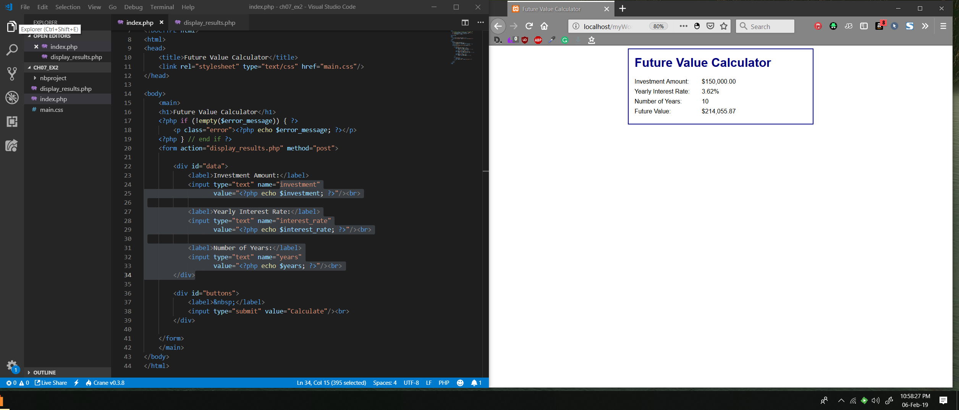

The names are investment, interest_rate, and years.

4. Modify the code so it uses drop-down lists instead of text boxes for the first two entries.

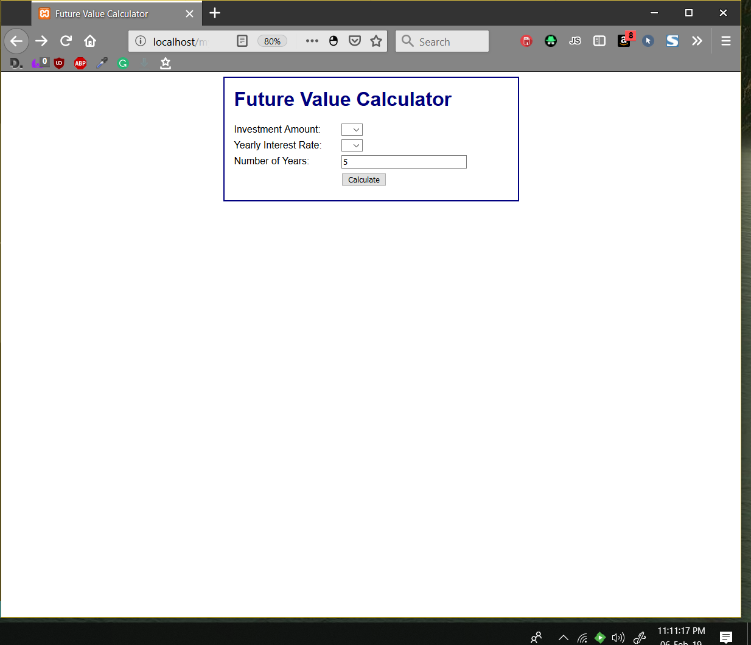

5. For the investment amount, the drop-down list should display values from 10,000 to 50,000 incremented by 5,000. To do this, you can use a for loop that creates the HTML for the drop-down list.

If you have any trouble with this, you may want to look ahead to the last example in figure 8-11 of the next chapter. Or, you can come back to this after you read chapter 8.

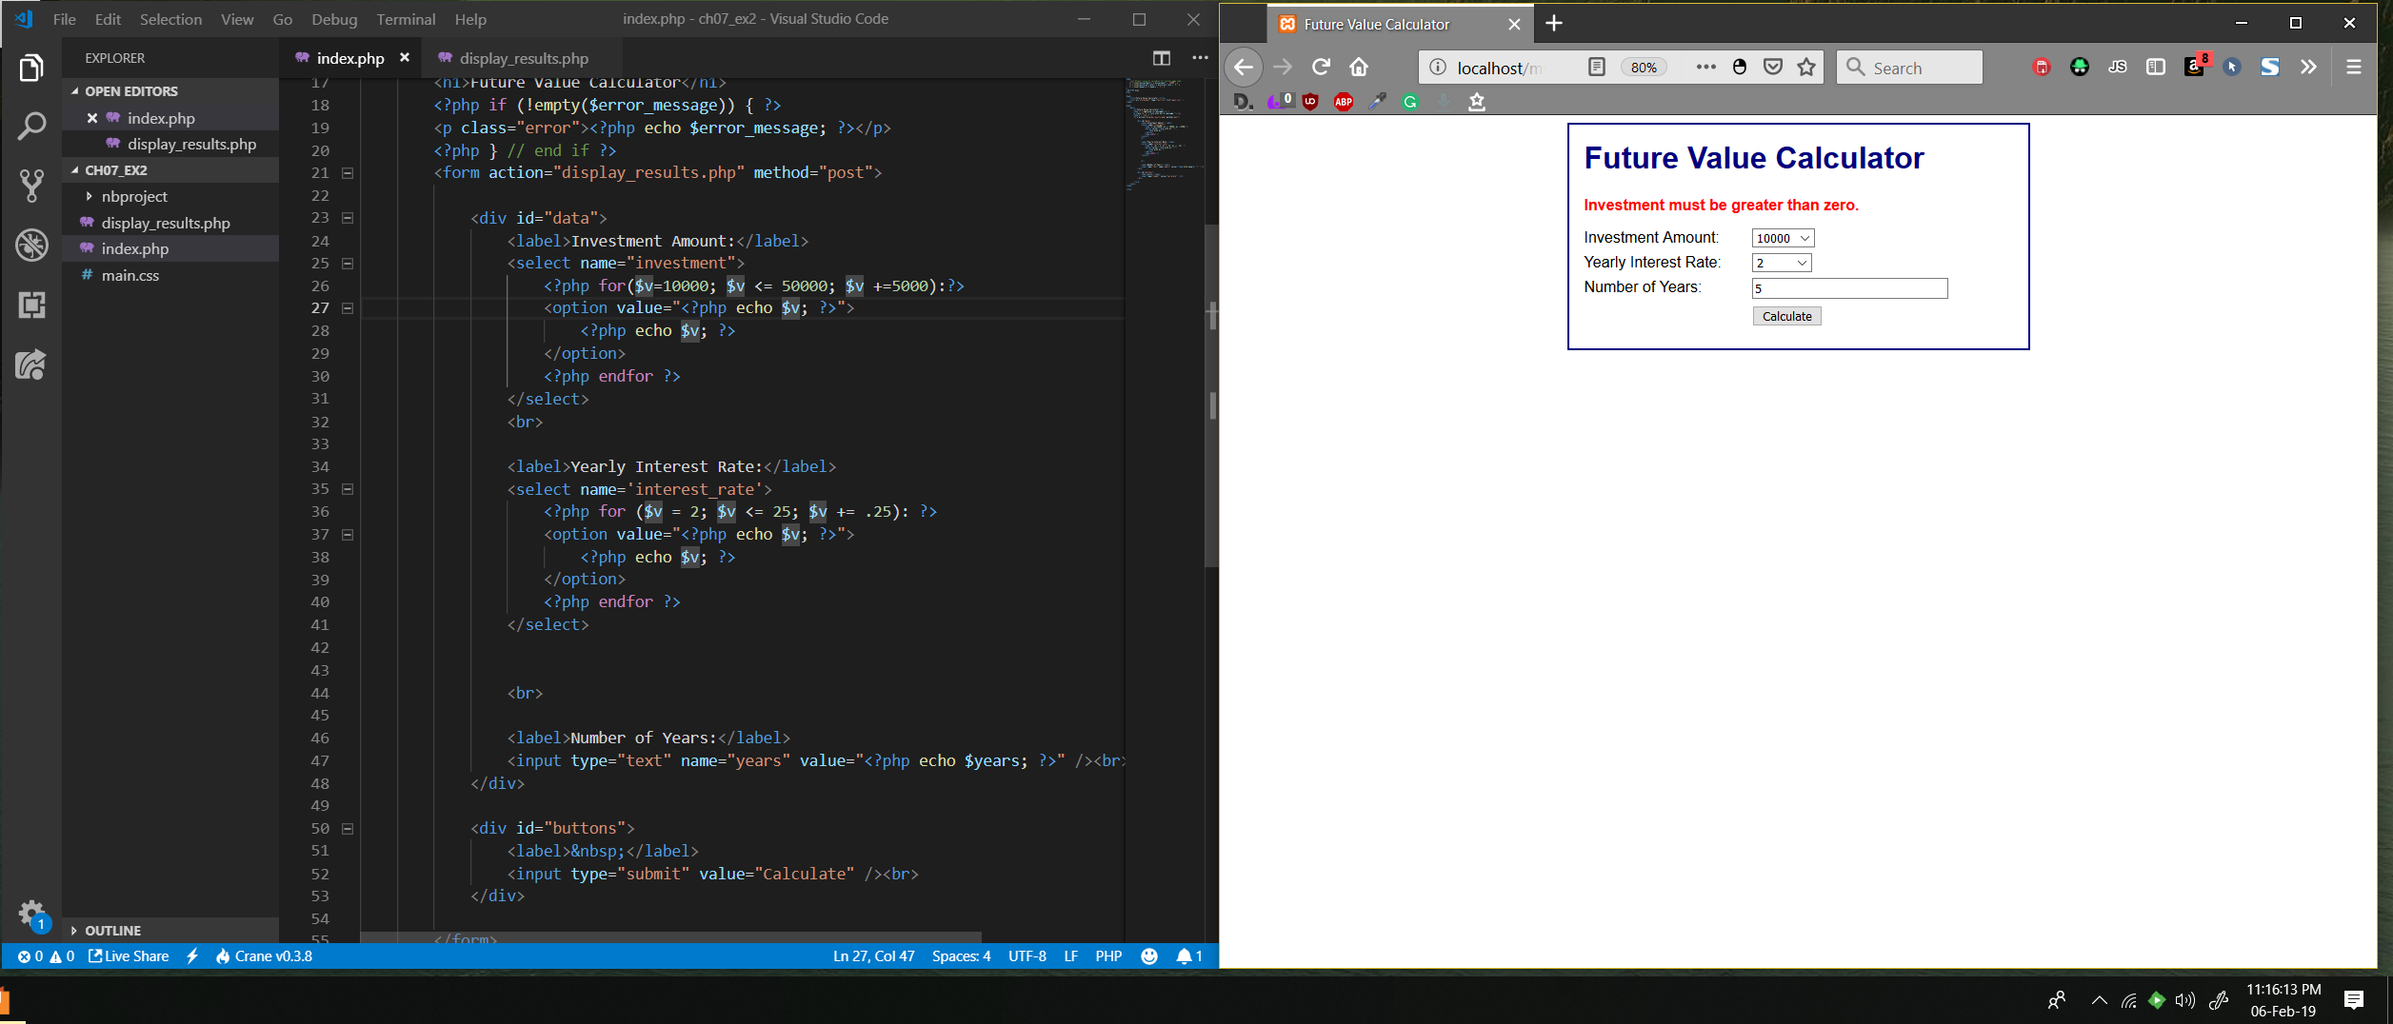

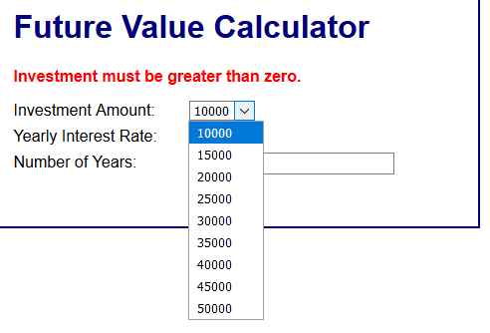

6. For the yearly interest rate, the drop-down list should display values from 4 to 12 incremented by .5.

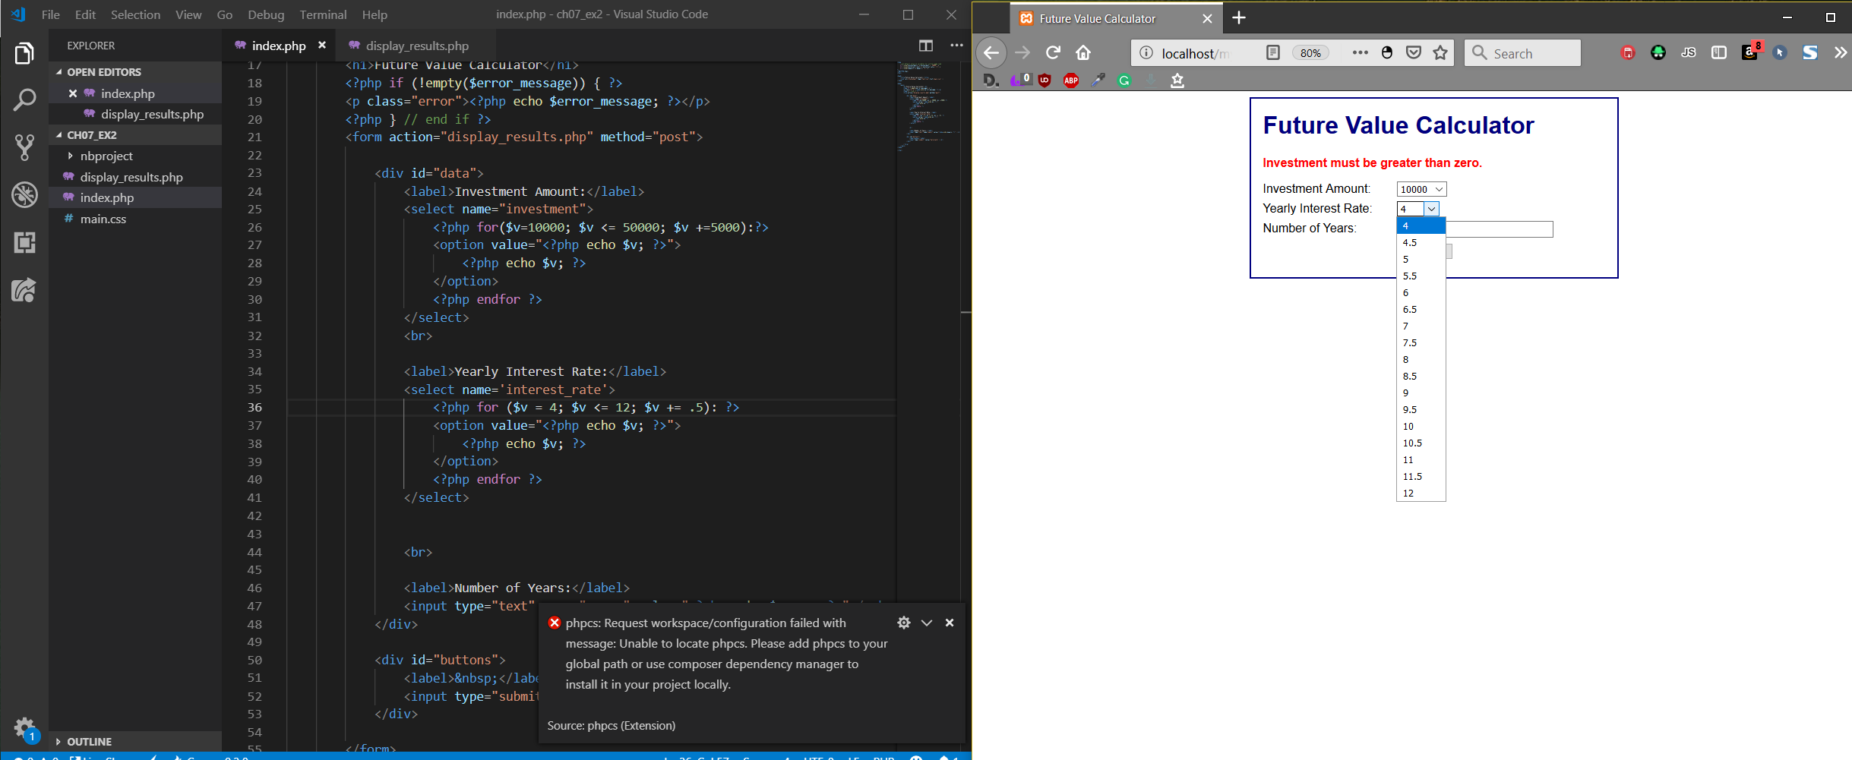

7. Test the application to make sure it works correctly.

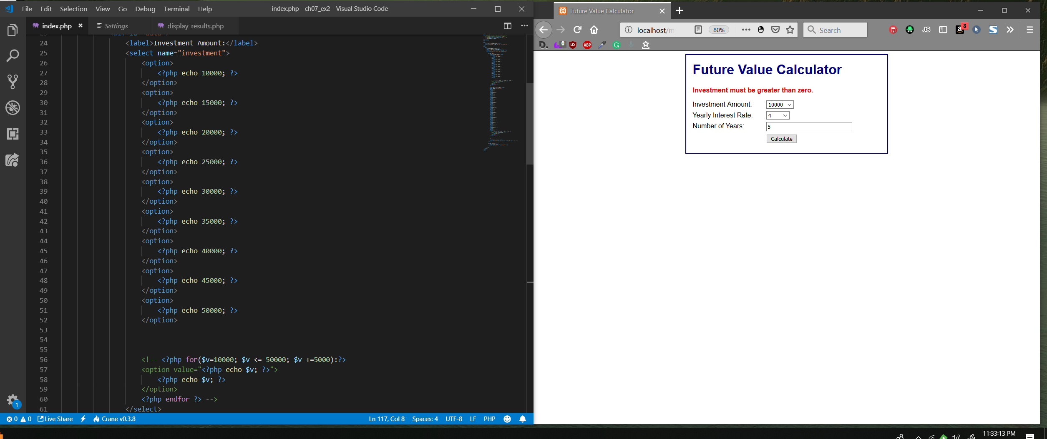

The options are showing up. I had to remove the for loops because I saw your instructions after looking at chapter 8.

There are 7 steps in this exercise on page 232.  Do each of the steps.  If the step has you do activity similar to view a page, make sure you show the page/code of that in your screen shot.

Step 3 has you take note of certain names.  On those screen shots highlight or otherwise indicate those names they want you to take note of for those steps.

Step 5 and Step 6 - In each of these two steps they have you fill drop down list contents.  The authors tell you to look ahead to Chapter 8 to do so with the For loop.  I would like to not look ahead but to do that fill manually.  This will create a longer set of code and may require extra screen shots.  Do not use a FOR loop for populating those controls in steps 5 and 6.

Not in the Book exercise

Using the examples in the text and your exercises as your guide, create a page that is stylish and collects the Name and Address information from the user.  Display that information in a standard 3 line address format after the user is done.  Do not make this a simple black and white few pages, add style into it.  When you test it for the screen shot, find the fictional address of one of your favorite TV Characters and use that information as your test.

Put all of the screen shots into a word document with the header for this class and the complete code from the exercise into a zipped submission file. When complete, the submission file should be uploaded into the Drop Box.

